Development Costs
Sage projected the site development and build costs using the Marshall and Swift Valuation Service (MVS). The most current costing data and the most appropriate multipliers were used. The most similar available asset class for cost comparison to the subject development is the manufactured housing park segment of MVS. These are rated from cheap, low cost, average, good, and excellent levels. The ‘Excellent’ level rating was selected for a manufactured home development based on the project description. The MVS costing data per site and description can be viewed below.
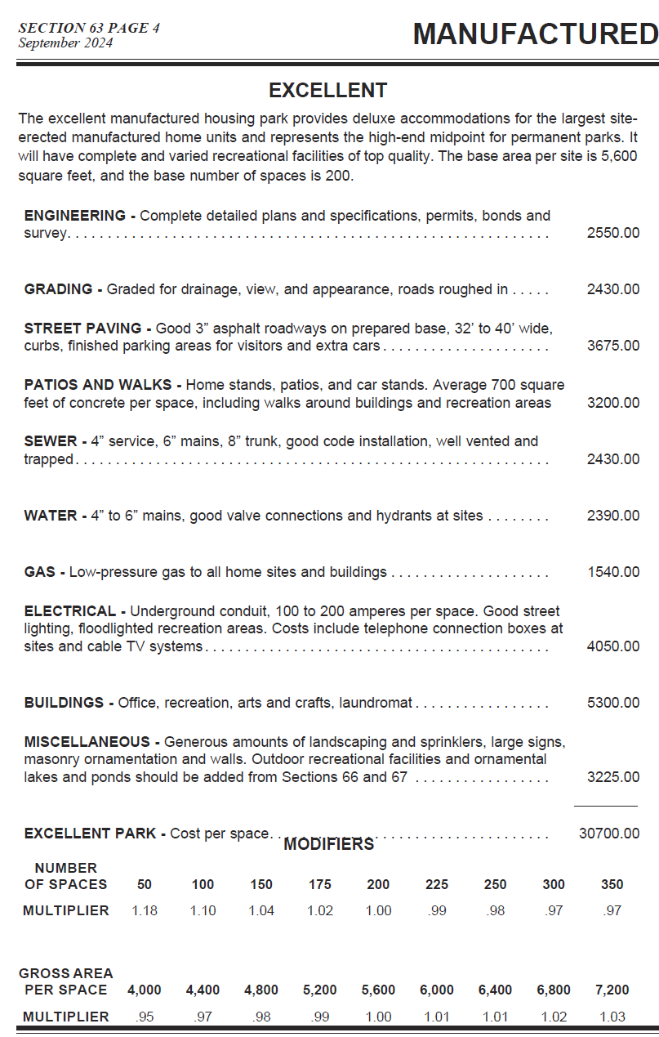
SOURCE: MVS
Once the site cost is estimated, cost multipliers are applied to adjust for time, local labor, and the cost of goods, as well as site-specific characteristics.

Multipliers
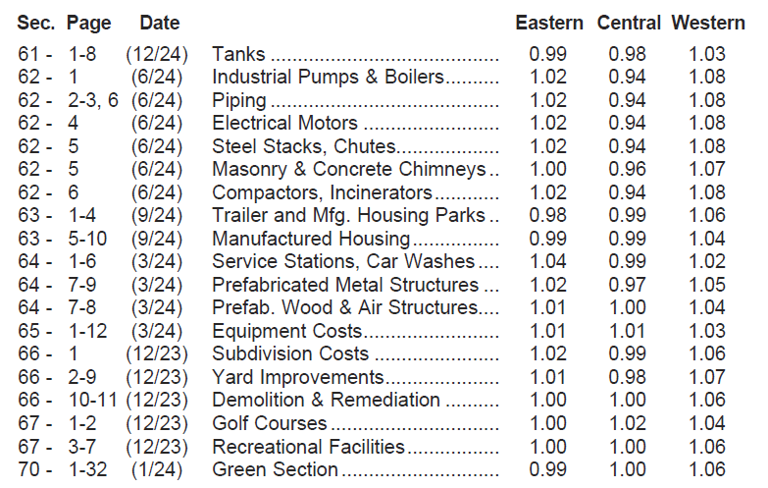
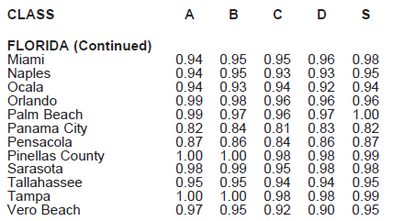
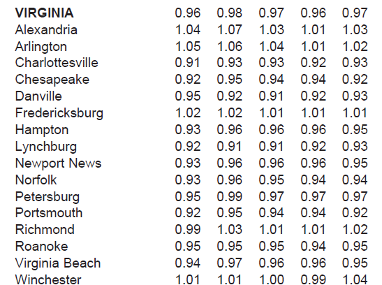
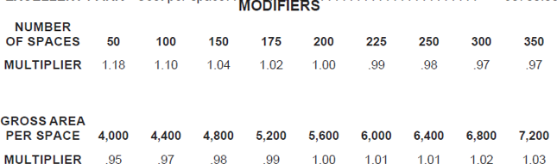
SOURCE: MVS
Incorporating the unique cost multipliers specific to the subject site, the MVS projected development cost for the subject site can be seen below.

Site Development Costs

Unit Costs

Additional Structures and Site Improvements

Permanent structure on the site will include:

Personal Property
Items classified as personal property are as follows:

Total Project Cost

